Computer Sciences Department , Level 5  **Submitted by:**



**الوولكت العربيت السعىديت**

**وزارة التعلين**

**ج**

**ــ**

**اه**

**ـ**

**ع**

**ـ**

**ت الأهي**

**ــ**

**ر س**

**ـ**

**ط**

**ــ**

**ام بن عبدالع**

**ـ**

**سي**

**ـ**

**س**

**كليت الهن**

**ـ**

**دسـ**

**ــ**

**ت و عل**

**ىم الحــاسـب**



**Kingdom of Saudi Arabia**

**Ministry of Education**

**Prince Sattam Bin Abdulaziz**

**University**

**College of C**

**omputer**

**E**

**ngineering**

**and S**

**cience**



**A Project Report on**

**S**

**EH**

**H**

**ATY**

Female Section, Al

-

Aflaj



|  |  |  |
| --- | --- | --- |
|  | **Student Names** | **Student Number** |
| **1.** | **Wejdan Hamd Al-hamdan** |  |
| **2.** | **Waad Fahad Al-othimeen** |  |
| **3.** | **Layan Saad Al-muhammisah** |  |
| **4.** | **Bayan Saeed Al-hamdan** |  |

### Supervisor by :

### Dr. Muhammad Saad Asiri

**Year: 2023**

# 1 . Feasibility Study & Project Proposal

## 1.1 Introduction

The Sehhaty application is the unified application for providing integrated health care to facilitate services for individuals , and serves more than 29 million citizens and residents and achieved more than 203 million registered medical appointments, 6 million remote appointments and 700 thousand immediate medical consultations .

## 1.2 Problems

**KSA have is noticed many problems in the care health system faced by the ministry of health and its citizens . The problems some are as follows:**

1. Difficulty booking medical appointments manually
2. .Difficulty extract the medical record and reports
3. Difficulty booking medicals appointment remotely
4. Difficulty get result of medical Imaging any time
5. Difficulty finding a specialist doctor any time
6. Difficulty of immediate medical consultations

## 1.3 Background

Saudi Ministry of health their vision is " A Country Pulsing Health " attention to public health and Disease Control has been one of the priorities of the Saudi government since the first beginnings of uniting the Kingdom and building the Saudi state by the founding King Abdulaziz bin Abdulrahman Al Saud- God's mercy

## 1.4 Proposed Solution

A unified application that includes access to health care services for citizens to facilitate access to many health services such as: providing a better experience for booking health appointments, reviewing prescriptions in addition to services and features to enhance the practice of walking, special services for women's health, and adding medications and reminders

**The Methodology** in the proposed application is an **Agile Methodological Approach** , because the health services of the application are increasing based on the health needs of citizens .

## 1.5 Work Plan

Sehhaty application seeks an integrated health system that takes care of the health care of citizens and residents in the kingdom of Saudi Arabia to facilitate access to health services and within the kingdom's digital transformation that provides many quality services and unique benefits .

He urged the Saudi Ministry of Health to provide the best experience of healthcare services to citizens and residents in booking appointments, reviewing prescriptions, reports and many others .

The Saudi Ministry of Health is interested in Sehaty Application To provide many health services in several areas ,

### - Sehhaty system it focuses many care health :

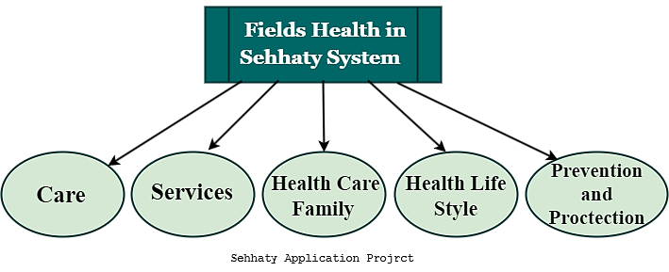

Some of the fields health In the application sehhaty have a multiple department of services

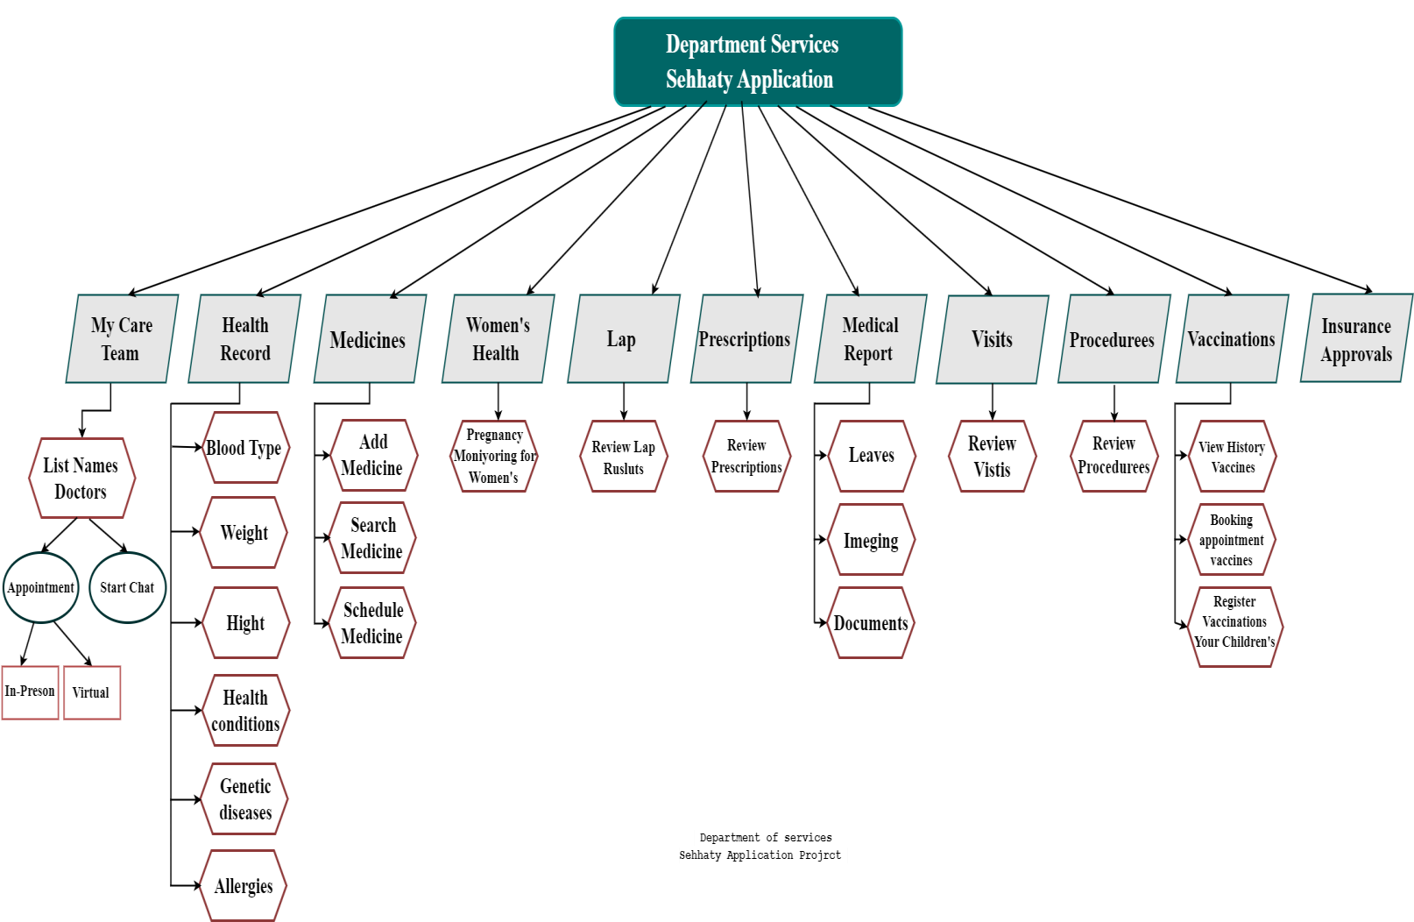

-

**Department of services in seh**

**h**

**aty application :**

# 2 . Project Requirement

### 2.1 Functional Requirements

1. Log In
2. Create account
3. Forget password
4. Update Mobile number
5. OTP validations
6. Book and review the health appointment schedule
7. Remote appointment
8. Calculation the steps
9. Weather early warning for asthmatics

* **My care teams**

1. View list of the doctor

* Health record
  1. View and choose blood type
  2. View and add weight
  3. View and add Height
  4. Follow-up of vital signs
  5. View and add health conditions
  6. View and add genetic diseases
  7. View and add allergies ( drug , Food , substance )
* **Medication** 
  1. Search medicine
  2. Add new medicine
  3. Schedule and view medications
* **Women's health** 
  1. Pregnancy monitoring for women's
* **Lap** 
  1. View Lap Results
* **Prescriptions** 
  1. View Results prescription
* **Medical Reports** 
  1. Reviews list of leaves
  2. Reviews list of Imaging
  3. Reviews list of medical documents
* **Visits** 
  1. View history visits
* **Procedures** 
  1. View history procedures

* **Vaccines**

1. View history of vaccines
2. Book appointment vaccines
3. Register vaccinations your children's

10. Log in

### 2.2 Non-Functional Requirements

1. Availability
2. Performance
3. Usability
4. Reliability

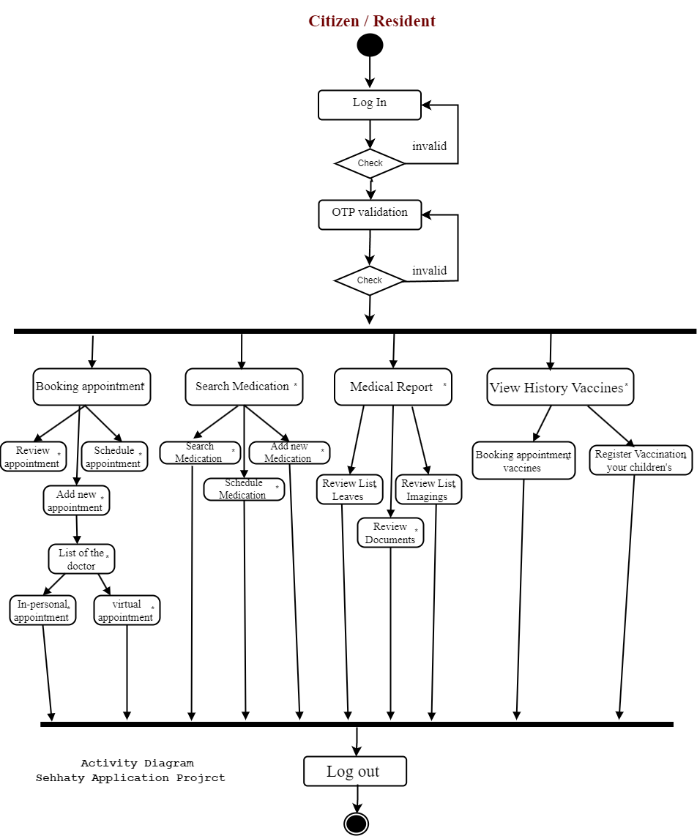

**3**

**. Activity**

**diagram**

# 4 . Project Use Case Modeling

### 4.1 Project Use Case Table

**Health field have many of user in the system , but in Sehhaty**

### Application have 3 user (citizen , resident , visitor )

# Table 1 : Citizen

|  |  |
| --- | --- |
| **Actor** | **Citizen and log in sehhaty** |
| **Description** | **A Citizen can access the health service if you have an account, log in and be validated by sending SMS to the mobile number** |
| **Data** | **National ID , password , OTP code** |
| **Stimulus** | **A Citizen needs view and booking in the health services** |
| **Response** | **Access to health service such as: ( view services , booking appointment and schedule , health record , calculation the steps , Medication )** |

# Table 2 : Resident

|  |  |
| --- | --- |
| **Actor** | **Resident and log in sehhaty** |
| **Description** | **A Resident can access the health service if you have an account, log in and be validated by sending SMS to the mobile number** |
| **Data** | **Iqama ID , Password , OTP code** |
| **Stimulus** | **A Resident needs view and booking in the health services** |
| **Response** | **Access to health service such as: ( view services , booking appointment and schedule , health record , calculation the steps , Medication )** |

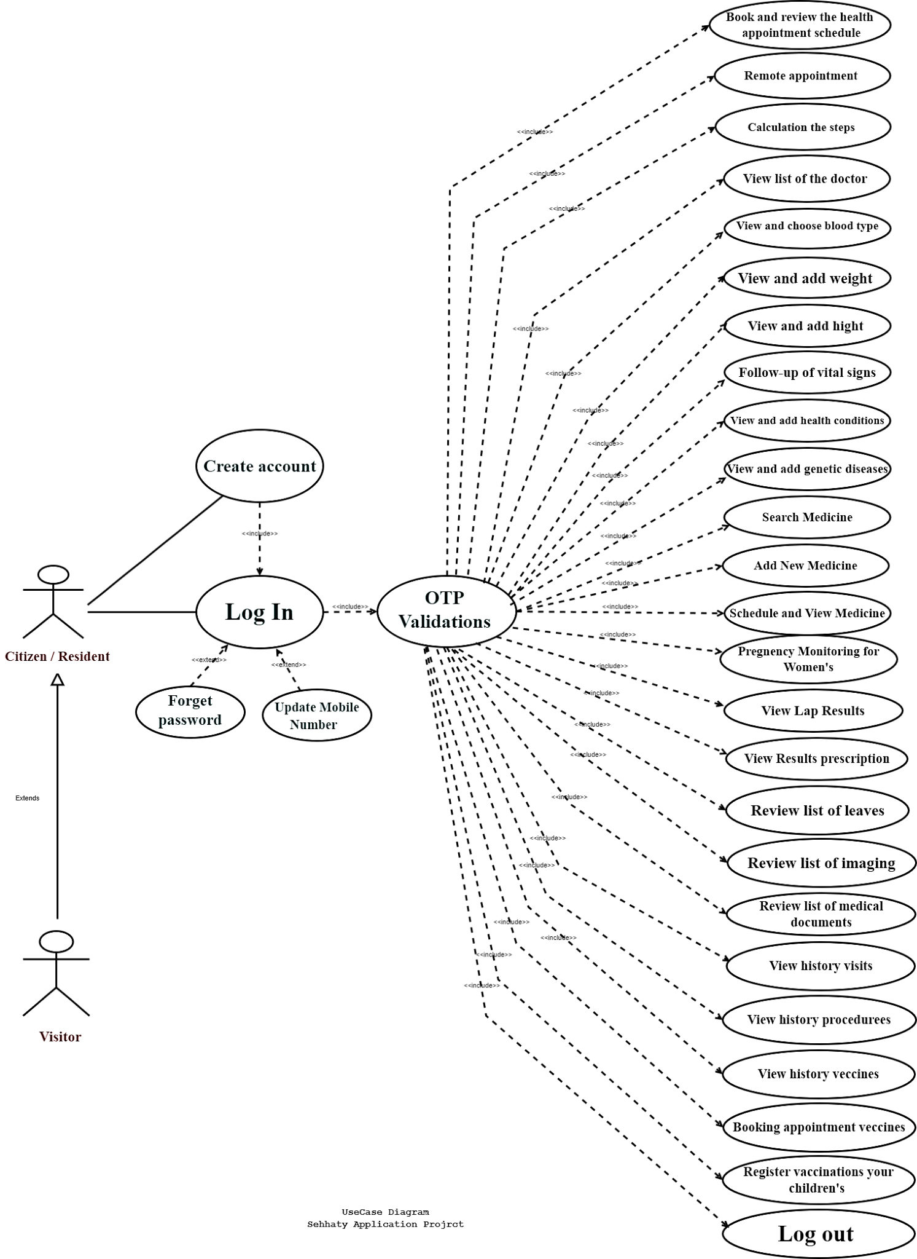

**4**

**.**

**2**

**Project Use Case Diagram**

# 5. Sequence Diagrams

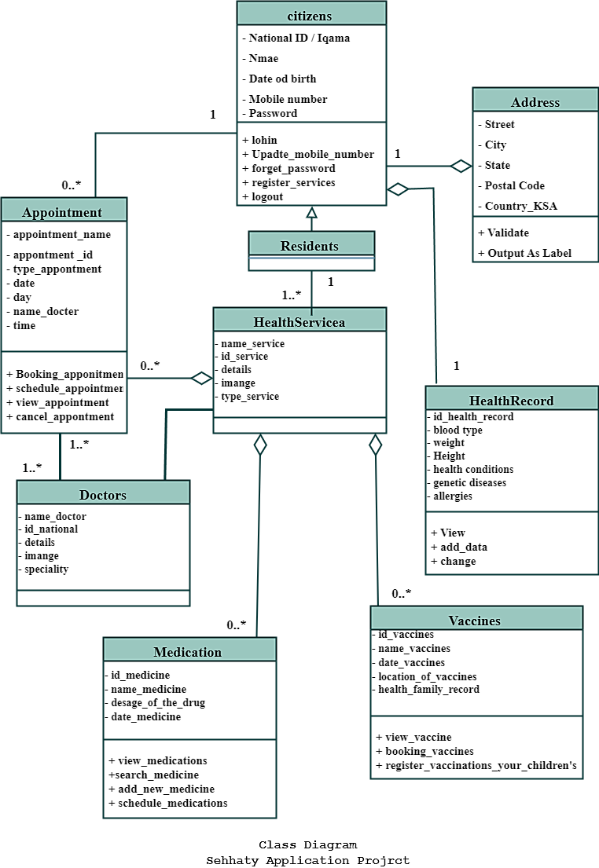

**6**

**.**

**Class**

**Diagrams**

# References

* SOFTWARE ENGINEERING Ninth Edition Ian Sommerville
* Ministry of Health KSA Website
* Sehhaty Application
* Sehhaty Website